Single container pod

vi singlecon.yml

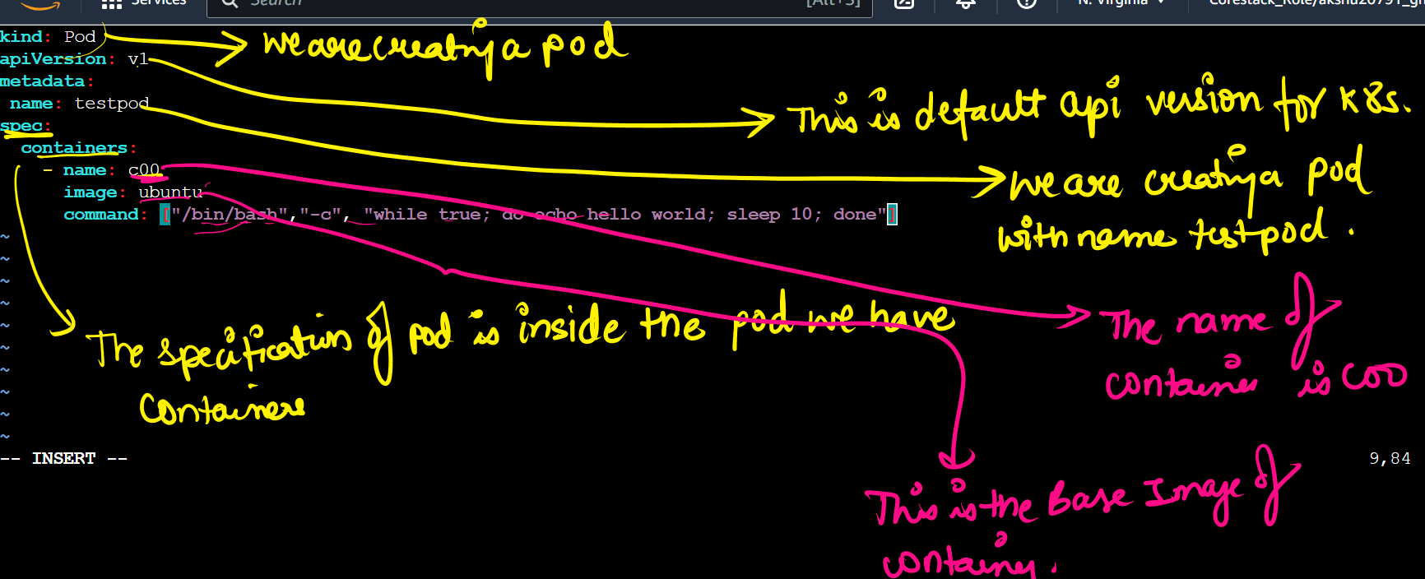

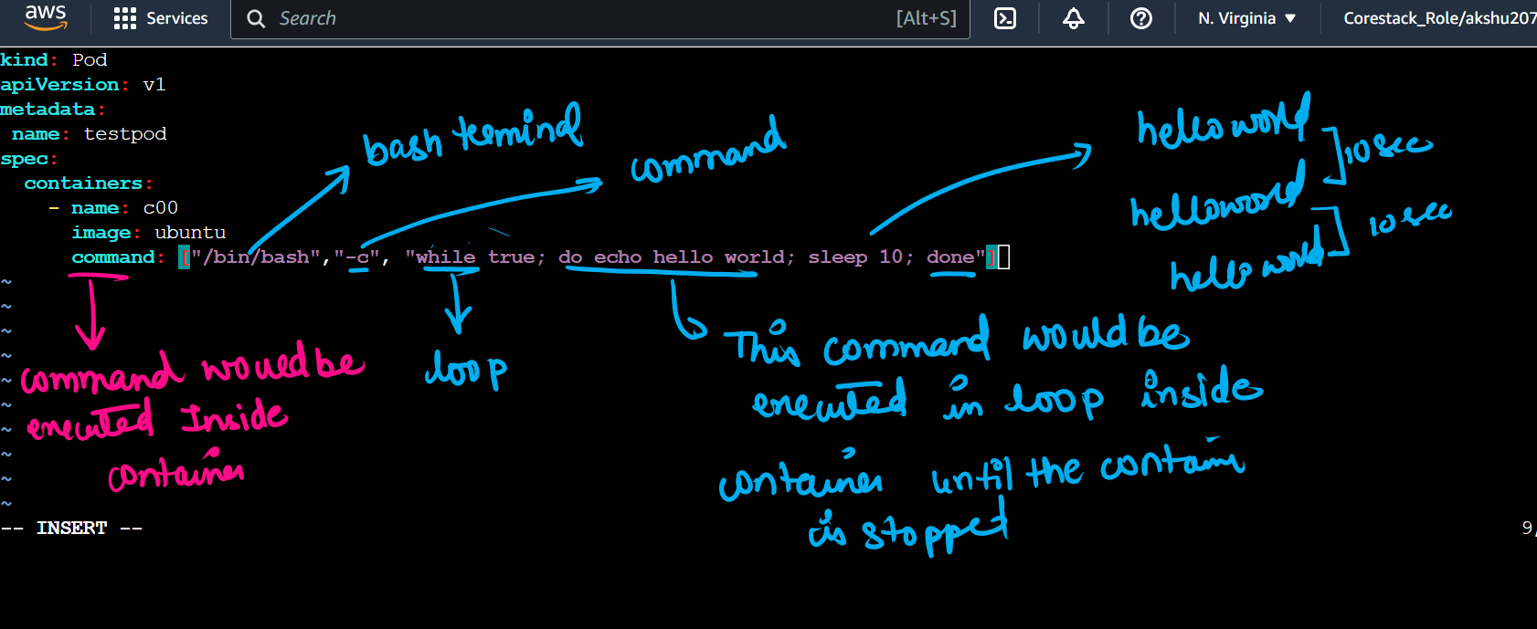

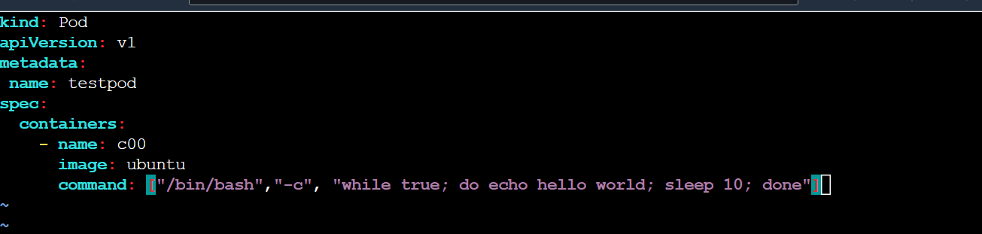

kind: Pod

apiVersion: v1

metadata:

name: mypod

spec:

containers:

- name: c00

image: ubuntu

command: ["/bin/bash", "-c","while true; do echo hello world; sleep 10; done"]

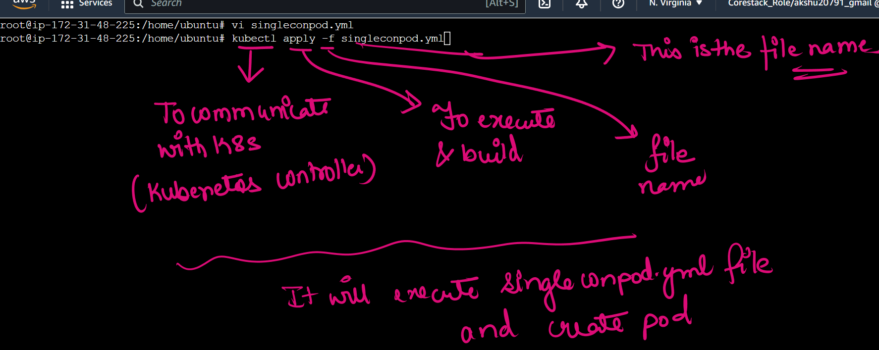

## list the pods

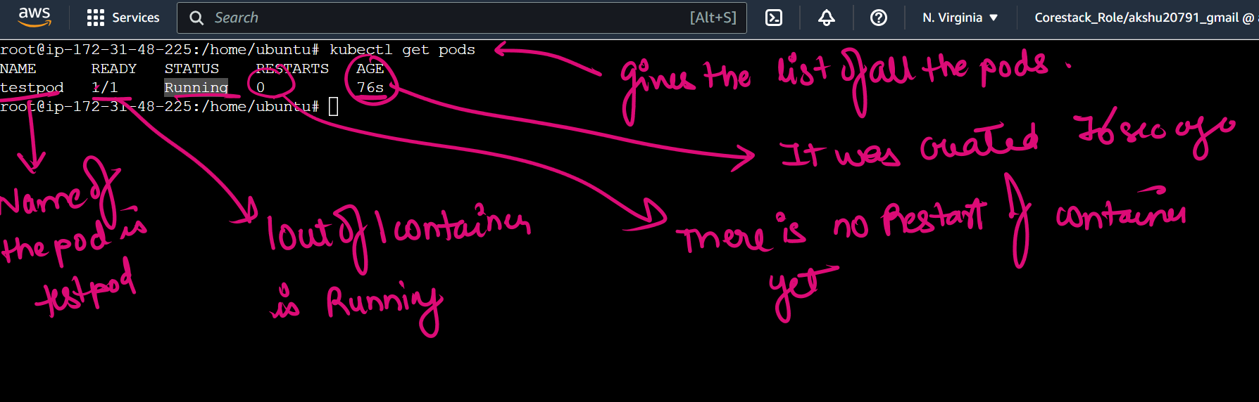

## to find in which node the pod is created

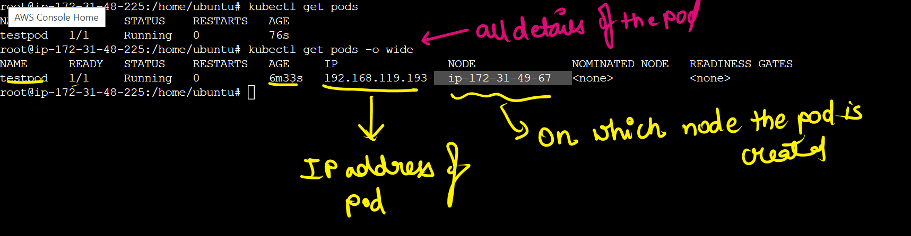

## to see what is running inside the container

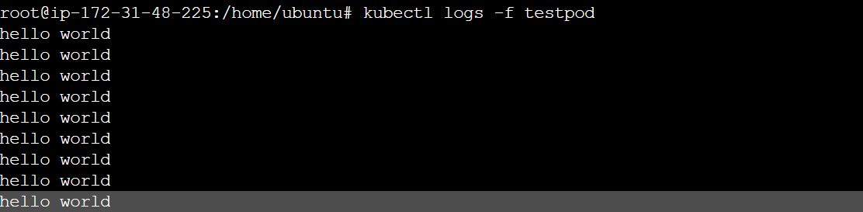

Press ctrl c to come out